Case Study myRetail RESTful service

Technologies/Tools Used for Case study

1. Spring Boot 1.4.2.RELEASE
2. Spring Security (Basic authentication)
3. Eh Cache
4. Swagger 2.6.1 using Springfox API
5. Cassandra 2.1.8
6. Spring Data
7. slf4j logger
8. jUnit
9. Mockito
10. Maven 3
11. JDK 1.8
12. STS 3.9.0

How to run application:

The application can be started by running the below maven command

mvn clean install spring-boot:run

API Information Document

API Information is available under swagger UI below

<http://localhost:8080/swagger-ui.html#/>

username : myretail

password : myretail

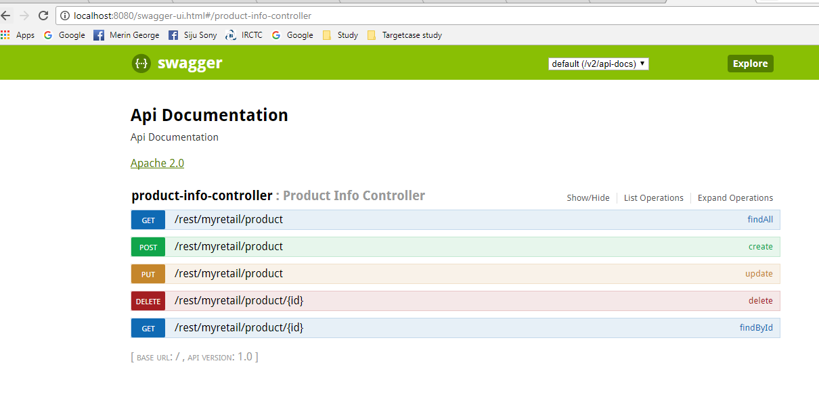

Get Request Info

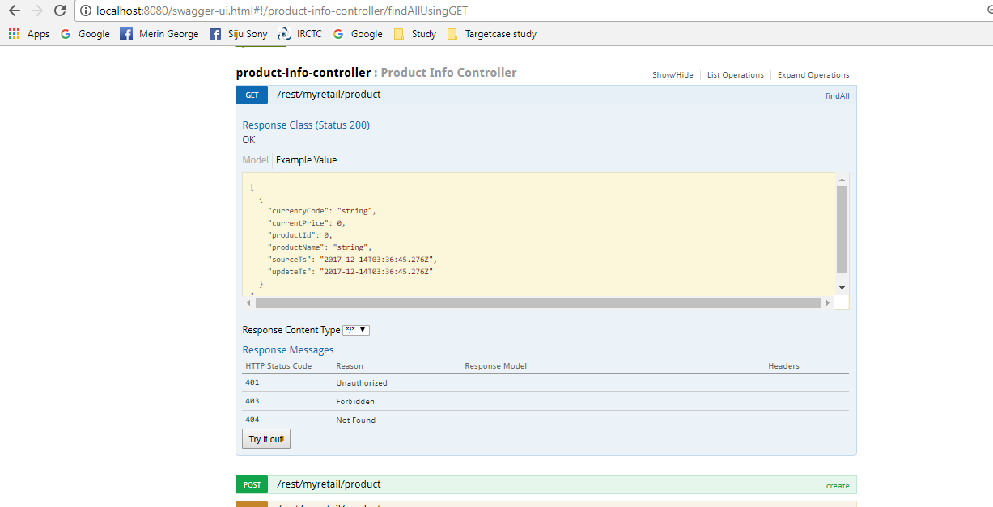

POST Request Info

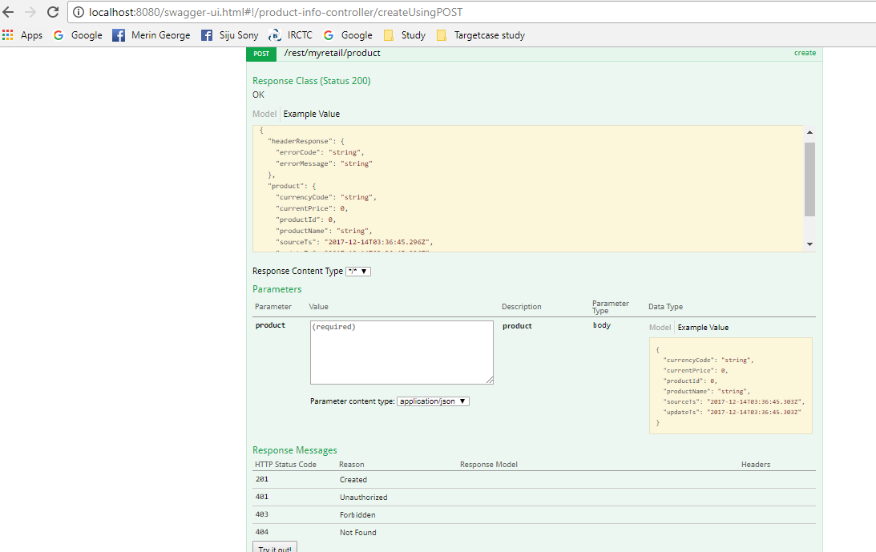

Testing Application:

Testing for the application was performed using Postman and junit test cases.

1. Get Request :

Authentication: usr/pswd : myretail/myretail

Request: <http://localhost:8080/rest/myretail/product/13860428>

Response:

{

"product": {

"productId": 13860428,

"sourceTs": 1512994332000,

"updateTs": 1513167132000,

"productName": "The Big Lebowski (Blu-ray)",

"currencyCode": "USD",

"currentPrice": 123.33

},

"headerResponse": {

"errorCode": "200",

"errorMessage": "SUCCESS"

}

}

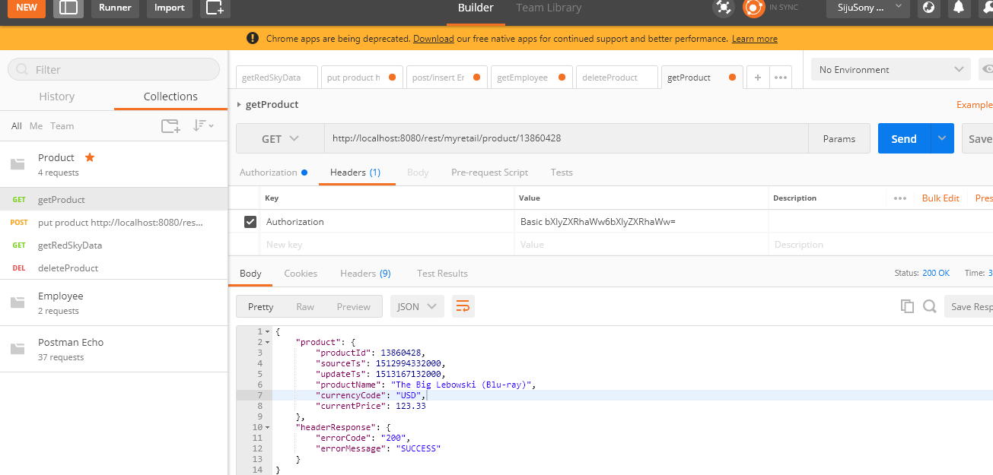

1. POST Request :

Authentication: usr/pswd : myretail/myretail

Request URL : http://localhost:8080/rest/myretail/product

Request:

{"productId":13860428,

"sourceTs":"2017-12-11T12:12:12",

"updateTs":"2017-12-13T12:12:12",

"productName":"Test",

"currencyCode":"USD",

"currentPrice":123.33

}

Response:

{

"product": {

"productId": 13860428,

"sourceTs": 1512994332000,

"updateTs": 1513167132000,

"productName": "Test",

"currencyCode": "USD",

"currentPrice": 123.33

},

"headerResponse": {

"errorCode": "201",

"errorMessage": "SUCCESS"

}

}

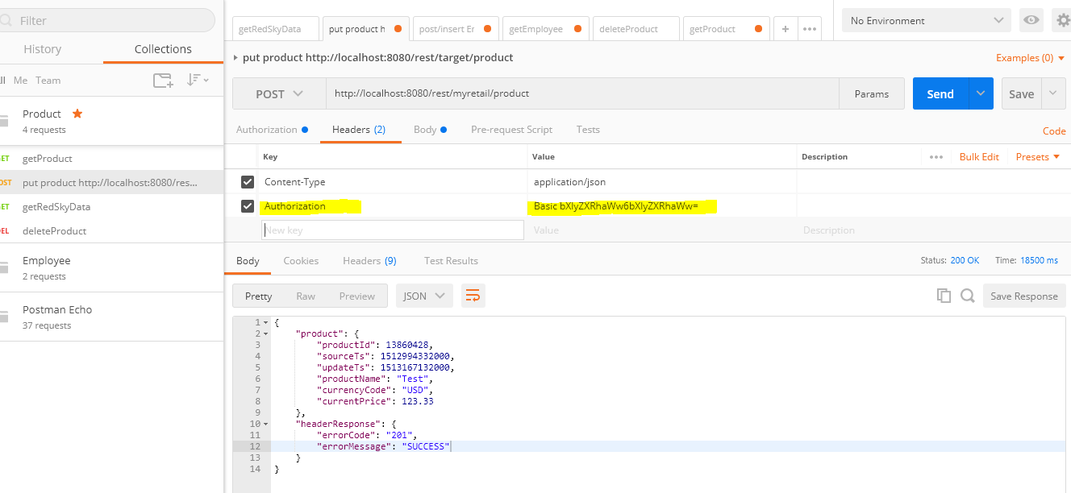

Delete Request:

URL : <http://localhost:8080/rest/myretail/product/13860428>

GET ALL

URL : <http://localhost:8080/rest/myretail/product/>

Cassandra table Format

Table is designed in such a way that the latest record for a particular product is always available as first record

CREATE TABLE price_info (

product_id bigint,

source_ts TIMESTAMP,

update_ts TIMESTAMP,

product_name TEXT,

current_price DOUBLE,

currency_code TEXT,

PRIMARY KEY ((product_id), source_ts, update_ts)

) WITH CLUSTERING ORDER BY (source_ts DESC, update_ts DESC);

